

**Deployment Document**

Landlord Management System

**Version 1.1**

18th July 2022

# Disclaimer

Information in this document is subject to change without notice. The software described in this document is furnished under a license agreement or nondisclosure agreement. The software may be used for copying, only in accordance with the terms of those agreements. No part of this document may be reproduced, stored in a retrieval system, or transmitted in any form or any means electronic or mechanical, including photocopying and recording for any purpose other than the purchaser’s personal use without the written permission of Eppix eSolution Limited.

All trademarks used herein are properties of their respective owners.



Table of Contents

Disclaimer 2

1. Deployments: 5

2. Server Link Configuration 6

3. Logo Configuration 7

4. Workgroups Configuration 8

5. Monitor DB Configuration 9

6. To Login In Enterprise asset manager 10

7. Host Parameter Configuration: 10

8. Local Password Configuration: 14

9. Billingcore configuration 15

10. Truebylui Configuration 16





# Deployments:

* Deploy following released items in Tomcat webapps directory
  1. RuleServer.war
  2. enterpriseassetmanager.war
  3. signup.zip
  4. usermanagement.zip
  5. workflow.zip
  6. landlordselfservice.zip

* Unzip all the zip files by unzip *.zip command
  1. signup.zip
  2. usermanagement.zip
  3. landlordselfservice.zip
* To change env.js
  1. Go inside each of signup, usermanagement, workflow, landlordselfservice.
  2. Change env.js
* Replace all http://localhost:8080/ with the actual server port or load balancer server port (if any) values

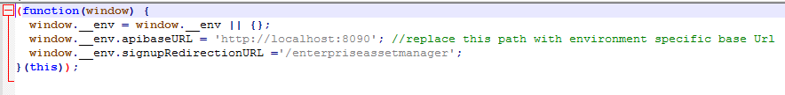

* Copy ‘rewrite.config’ to apache-tomcat-9.0.56\conf\Catalina\localhost directory
* Copy ‘web.xml’ to apache-tomcat-9.0.56\webapps \ROOT\WEB-INF directory
* Copy the ‘static’ directory inside apache-tomcat-9.0.56\webapps.
* Copy the ‘images’ directory inside apache-tomcat-9.0.56\webapps
* Copy mysql-connector-java-8.0.22.jar & postgresql-42.2.18.jar to apache-tomcat-9.0.56\lib directory
* PARE Server setup

1. Create a directory named PAREDeployBundles inside the user home directory

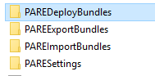

1. Copy all zip files from server/bundles folder



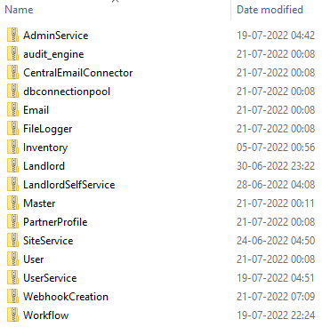

1. Startup Tomcat

# Server Link Configuration

* Run PareStudio in local desktop
* Create a Server Link to the PARE Server
  1. Go to PARE
  2. Select settings tab
  3. Under the settings tab select server Links

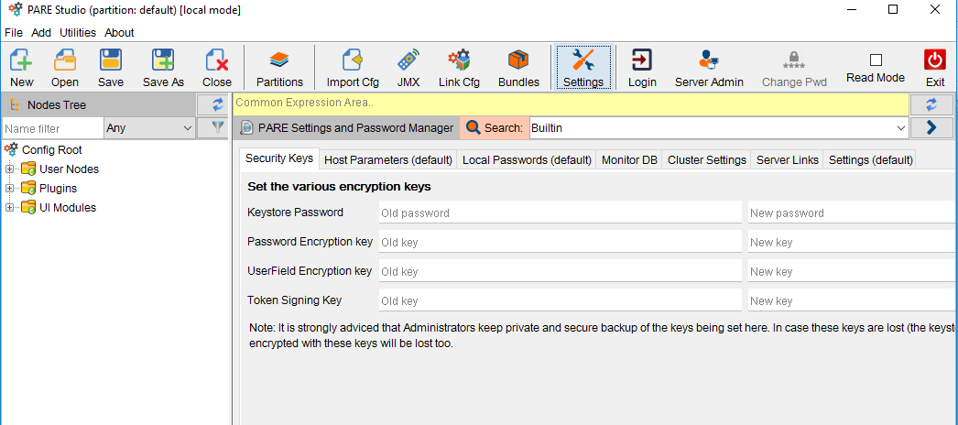

* 1. After selecting server link provide-
* **Name** = <Identifier of the link i.e. any name>
* **Protocol** = https
* **Host** = <Deployment server IP address where Tomcat is running>
* **Port** = <Tomcat HTTP/HTTPS request listening port>
* **Username** = admin
* **Password** = default
  1. Then add through  button .



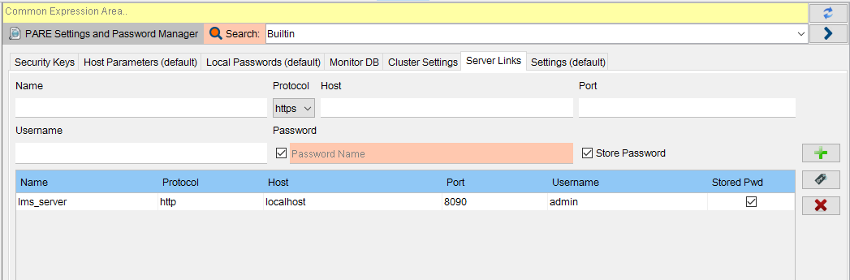

* 1. Go to Login tab for Login

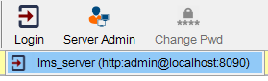

# Logo Configuration

* Open Remote Settings
  1. If any Change in ‘Default File Storage’ then set the path Click on Set button beside it

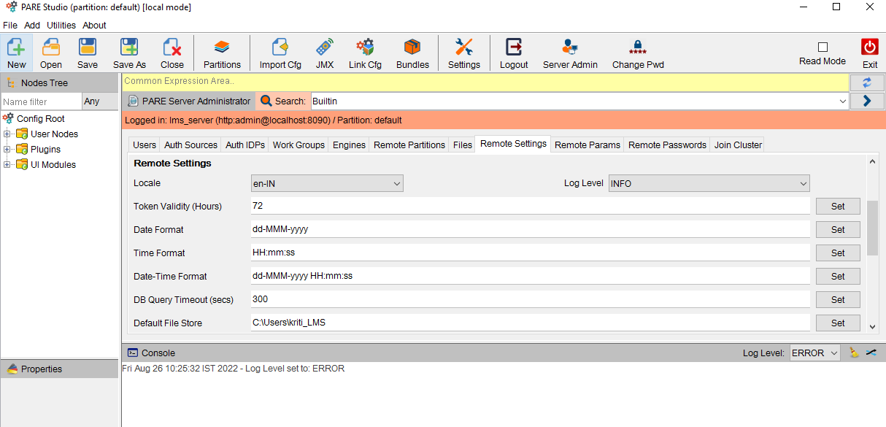

* Open ‘File’
  1. select ‘monitor’ in dropdown arrow
  2. Upload the Company Logo file which is to appear on Signup and Login pages throughout all LMS and LSS
  3. Once uploaded click on the icon beside the file. It will open the file in a browser, Copy the URL.



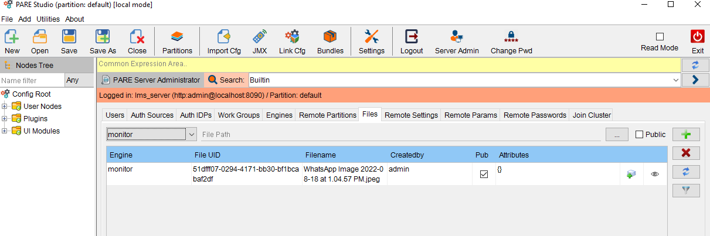

* Go to Remote Params
  1. Add a new param “auth_logo_url” with value as LOGO URL

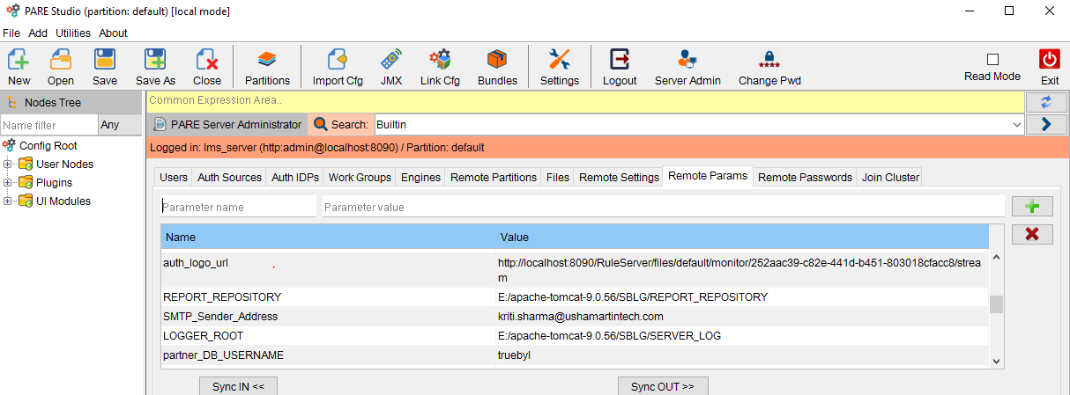



# Workgroups Configuration

1. Under the ‘Server admin’ tab select ‘Work Groups’ to Create a Workgroup named

* Customer Support
* Landlord Self Service

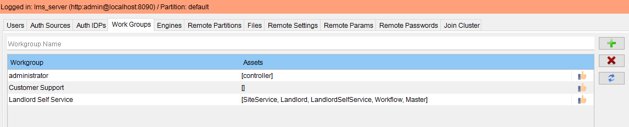

1. The Landlord Self Service workgroup should have following bundle permissions

* SiteService
* LandlordSelfService
* Landlord
* Workflow
* Master

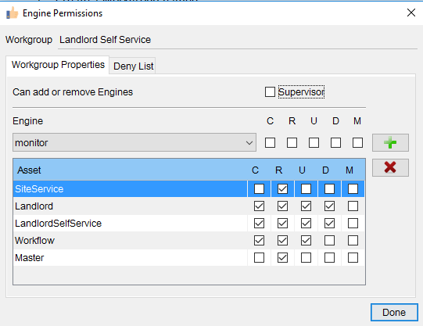

# Monitor DB Configuration

Under the settings tab select"Monitor DB" needs to be configured with the credentials of Master schema–

* **DB Type**= <Type of database i.e POSTGRESQL>
* **Driver Location**= <location of DB driver i.e postgresql-42.2.5.jar location for PostgreSQL driver>
* **Connection String**=<Connection string for DB i.e. jdbc:postgresql://<DB server IP>:<port>/<database name>?useSSL=false
* **Username**= <username of Master Schema>
* **Password**= <password of Master Schema>

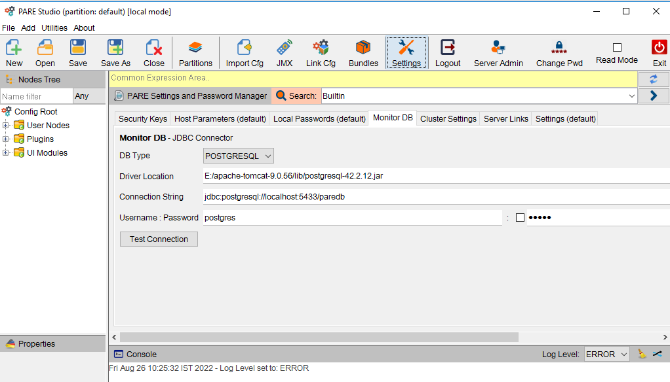



# To Login In Enterprise asset manager

1. Restart the tomcat server
2. In a browser go to http://server:port/enterpriseassetmanager. The login page should appear with the new logo uploaded.
3. Signup Partner

# Host Parameter Configuration:

Under the settings tab select “Host Parameters(default)” tab to Configure all Host parameters

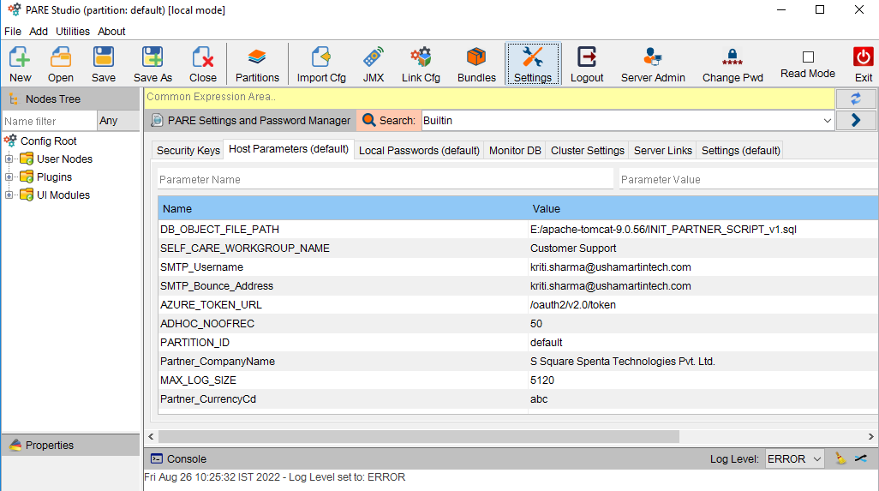

In the deployment server, following “Host parameters” need to be configured under “default” partition**-**

|  |  |  |
| --- | --- | --- |
| **Parameter name** | **Description** | **Sample value** |
| DB_OBJECT_FILE_PATH | Absolute Path pointing to the Partner Db script file(INIT_PARTNER_SCRIPT_v1.sql) | /root/SBLG/INIT_PARTNER_SCRIPT_v1.sql |
| SELF_CARE_WORKGROUP_NAME | Name of the workgroup to be associated with self-care users while creating self-care users automatically during partner signup | Customer Support |
| SMTP_Username | Email Login Username | demo.truebyl@ushamartintech.com |
| SMTP_Bounce_Address | Bounce email id | demo.truebyl@ushamartintech.com |
| AZURE_TOKEN_URL | Part of the Token URL after token | /oauth2/v2.0/token |
| ADHOC_NOOFREC | default value for adhoc number of records to be set as per requirement | 50 |
| PARTITION_ID | partition id for partner, set as default | default |
| Partner_CompanyName |  | S Square Spenta Technologies Pvt. Ltd. |
| MAX_LOG_SIZE | contains maximum size of log file in KB | 5120 |
| Partner_CurrencyCd | default value for partner’s CurrencyCd to be set as per required, but it will automatically change during Partner Profile creation | abc |
| SERVER_PROTOCOL | Protocol for Server i.e. http or https | http |
| auth_logo_url |  | https\://demo.truebyl.in\:7010/RuleServer/files/default/monitor/c043d74c-182a-4f81-8b65-c75853dc66c2/stream |
| REPORT_REPOSITORY | Absolute path of the directory where all report bundles are kept and from where the bundles are imported during partner creation | /root/SBLG/REPORT_REPOSITORY/ |
| SMTP_Sender_Address | Sender Email id | demo.truebyl@ushamartintech.com |
| LOGGER_ROOT | contains the logger root folder path | /root/SBLG/SERVER_LOG |
| partner_DB_USERNAME | DB Username for partner | truebyl |
| UMT_CompanyName | developers company name | S Square Spenta Technologies Pvt. Ltd. |
| EMAIL_TEMPLATE_PATH | Path where different email templates are stored in html format | /root/SBLG/TEMPLATE/ |
| SMTP_Host | Email server IP | mail4.ushamartintech.com |
| AZURE_BASE_URL | In AZURE_BASE_URL store the part of the URL before token | https://login.microsoftonline.com/ |
| AUDIT_TRAIL_MODBY | default value for ModBy for audit trail insertion, needs to set as per requirement | U11ADMIN |
| SERVER_PORT | Tomcat HTTP/HTTPS request listening port | 8080 |
| TEMPLATE_PATH | Path where different templates are stored | /root/SBLG/TEMPLATE |
| TRUEBYL_PARTNER_LOGO_URL | Contains the context name part of the URL, from where the logos will be accessible over http(s). Typically the value should be the directory name inside tomcat webapps, where logos are stored as files | images/ |
| AZURE_AUTH_URL | Part of the Authorize URL after token | /oauth2/v2.0/authorize |
| PostgreSQL_DRIVER_LOCATION | postgresql-42.2.5.jar  location of PostgreSQL | /usr/local/tomcat/lib/postgresql-42.2.8.jar |
| WEB_SWING_SERVER_URL | url for the web-swing server | https\://demo.truebyl.in\:5052/webswing-server/parestudio/ |
| PostgreSQL_CONNECTION_STRING | Connection string for PostgreSQL | jdbc\:postgresql\://db\:5432/truebyl?currentSchema\=truebyl |
| REPOSITORY_ROOT | Contains path of all templates and report description file | /root/SBLG/DOCGEN_REPOSITORY/ |
| TRUEBYL_PARTNER_LOGO_PATH | Contains the absolute path to a directory inside tomcat webapps where the partner logos will be stored as files | /usr/local/tomcat/webapps/images/ |
| TRUEBYL_AMS_SEARCH_RESULT_MAX_SIZE |  | 50 |
| TRUEBYL_OUTPUT_ROOT | path for home directory where several sub directories will be created to store bill gen/post output files/rating rejected or archived UDR files | /root/SBLG |
| AUDIT_REC_NOOFREC | default value of audit no. of records needs to be set as per requirement | 100 |
| SERVER_IP | Deployment server IP address where Tomcat is running | server |
| **SAP Interface for Landlord** | | |
| CREST_LMS_SAP_LANDLORD_REQ_FILE_REMOTE_USERNAME | Username for remote file in SAP Interface | sblgdemo |
| CREST_LMS_SAP_LANDLORD_REQ_FILE_PATH_LOCAL | Local path for SAP Interface | /root/SBLG/INTERFACE_FILES/FROM_LMS |
| CREST_LMS_SAP_LANDLORD_REQ_FILE_REMOTE_HOST | Remote host for SAP Interface for Landlord | 172.16.210.224 |
|  | | |

|  |  |  |
| --- | --- | --- |
| CREST_LMS_SAP_LANDLORD_REQ_FILE_PATH_REMOTE | Remote File Path for SAP Interface for Landlord | /home/sblgdemo/LMS/FROM_LMS |
| CREST_LMS_SAP_LANDLORD_RES_FILE_ARCHIVE_PATH | Archive path for SAP Interface for Landlord | /home/sblgdemo/LMS/FROM_SAP/ARCHIVE/ |
| CREST_LMS_SAP_LANDLORD_RES_FILE_REMOTE_HOST | Remote | 172.16.210.224 |
| CREST_LMS_SAP_LANDLORD_RES_FILE_PATH_REMOTE |  | /home/sblgdemo/LMS/FROM_SAP/ |
| CREST_LMS_SAP_LANDLORD_RES_FILE_REJECT_PATH |  | /root/SBLG/INTERFACE_FILES/FROM_SAP/REJECT/ |
| CREST_LMS_SAP_LANDLORD_RES_FILE_REMOTE_USERNAME |  | sblgdemo |
| CREST_LMS_SAP_LANDLORD_RES_FILE_DOWNLOAD_PATH |  | /root/SBLG/INTERFACE_FILES/FROM_SAP/ |
| **TT Interface for Sites** | | |
| CREST_LMS_TT_SITE_DATA_FILE_PATH_ARCHIVES |  | /root/SBLG/INTERFACE_FILES/FROM_TT/ARCHIVE/ |
| CREST_LMS_TT_SITE_DATA_FILE_PATH_DOWNLOADS |  | /root/SBLG/INTERFACE_FILES/FROM_TT/ |
| CREST_LMS_TT_SITE_DATA_FILE_PATH_DUPLICATES |  | /root/SBLG/INTERFACE_FILES/FROM_TT/REJECT/ |
| CREST_LMS_TT_SITE_DATA_FILE_PATH_REJECTED |  | /root/SBLG/INTERFACE_FILES/FROM_TT/REJECT/ |
| CREST_LMS_TT_SITE_DATA_FILE_PATH_REMOTE |  | /home/sblgdemo/LMS/FROM_TT/ |
| CREST_LMS_TT_SITE_DATA_FILE_REMOTE_HOST |  | 172.16.210.224 |
| CREST_LMS_TT_SITE_DATA_FILE_REMOTE_USERNAME |  | sblgdemo |
| **Rent Renewal** | | |
| CREST_LMS_Rent_Agreement_Renewal_CSV_Path |  | /root/SBLG/INTERFACE_FILES/INTERNAL/ |
| CREST_LMS_Rent_Agreement_Renewal_Receiver_Email_Id |  | abhra.chandra@truebyl.com |
| **SAP Payment Interface** | | |
| CREST_LMS_SAP_PAYMENT_ERROR_FILE_PATH | File path for SAP Payment Interface | /root/SBLG/INTERFACE_FILES/INTERNAL/ |
| **SAP Invoice Interface** | | |
| CREST_LMS_SAP_INVOICE_FILE_PATH_LOCAL | Local Path for SAP Invoice Interface | /root/SBLG/INTERFACE_FILES/FROM_SAP/ |
| CREST_LMS_SAP_INVOICE_FILE_PATH_REMOTE | File Path for SAP Invoice Interface | /home/billingcore/LMS/FROM_SAP/ |
| CREST_LMS_SAP_INVOICE_FILE_REMOTE_HOST | Remote Host for SAP Invoice Interface | 172.16.210.224 |
| CREST_LMS_SAP_INVOICE_FILE_REMOTE_USERNAME | Username for SAP Invoice Interface | sblgdemo |
| CREST_LMS_IT_TEAM_EMAIL | Receiver Email id for IT Team | abhra.chandra@truebyl.com |
| CREST_LMS_EMG_TEAM_EMAILID |  | abhra.chandra@truebyl.com |
| **Crest Data Import Process** | | |
| CREST_LMS_SITE_DATA_PATH | Path for site data | /LMS/lms_exchange/FROM_CREST/Process/Site/ |
| CREST_LMS_AGREEMENT_DATA_PATH | Path for Agreement Data | /LMS/lms_exchange/FROM_CREST/Process/Agreement/ |
| CREST_LMS_LANDLORD_DATA_PATH | Path for Landlord Data | /LMS/lms_exchange/FROM_CREST/Process/Landlord/ |
| CREST_LMS_ARCHIVE_FILE_PATH_AGREEMENT | Archive path for Agreement files | /LMS/lms_exchange/FROM_CREST/Archive/ |
| CREST_LMS_ARCHIVE_FILE_PATH_LANDLORD | Archive path for Landlord files | /LMS/lms_exchange/FROM_CREST/Archive/ |
| CREST_LMS_ARCHIVE_FILE_PATH_SITE | Archive path for site files | /LMS/lms_exchange/FROM_CREST/Archive/ |
| CREST_LMS_DOCUMENT_PATH | Path for Document Upload | /LMS/lms_exchange/FROM_CREST/Process/Documents/ |
| CREST_LMS_DOCUMENT_REJECTED_PATH | Path for Rejected Document | /LMS/lms_exchange/FROM_CREST/Reject/ |
| CREST_LMS_REJECTED_FILE_AGREEMENT | Path for Rejected Agreements | /LMS/lms_exchange/FROM_CREST/Reject/ |
| CREST_LMS_REJECTED_FILE_LANDLORD | Path for Rejected Landlords | /LMS/lms_exchange/FROM_CREST/Reject/ |
| CREST_LMS_REJECTED_FILE_SITE | Path for Rejected Sites | /LMS/lms_exchange/FROM_CREST/Reject/ |
| **Galaxy Integration** | | |
| CREST_LMS_GALAXY_LOGIN_API_URL |  | http://www.in3.co.in:8080/LMS/login |
| CREST_LMS_GALAXY_LOGIN_API_USERID |  | Trinity |
| CREST_LMS_GALAXY_REJECT_API_URL |  | http://in3.co.in:8080/LMS/rejectMeterReading |
| CREST_LMS_GALAXY_METER_READING_API_URL |  | http://in3.co.in:8080/LMS/getMeterReading |
| **SAP Payment Interface** | | |
| CREST_LMS_SAP_PAYMENT_ERROR_FILE_PATH |  | /LMS/lms_exchange/FROM_SAP/REJECT/ |
| CREST_LMS_SAP_LMS_PAYMENT_SFTP_CONNECTOR_HOST |  | 172.16.210.224 |
| CREST_LMS_SAP_LMS_PAYMENT_SFTP_CONNECTOR_USERNAME |  | sblgdemo |
| CREST_LMS_SAP_LMS_PAYMENT_LOCAL_FILE_PATH |  | /LMS/lms_exchange/FROM_SAP/ |
| CREST_LMS_SAP_PAYMENT_ERROR_FILE_PATH |  | /LMS/lms_exchange/FROM_SAP/REJECT/ |
| CREST_LMS_SAP_LMS_PAYMENT_LOCAL_ARCHIVE_FILE_PATH |  | /LMS/lms_exchange/FROM_SAP/ARCHIVE/ |

# Local Password Configuration:

Under the settings tab select “Local Password(default)” tab to Configure Local Passwords.

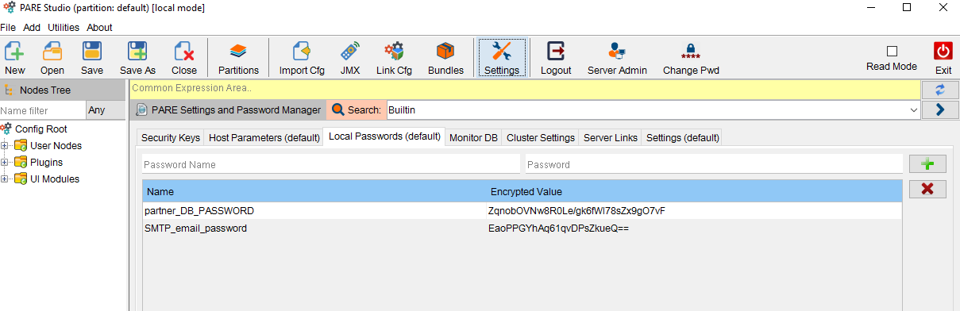

In the deployment server, following “Local Passwords” need to be configured under “default” partition –

|  |  |  |
| --- | --- | --- |
| **Parameter name** | **Description** | **Sample value** |
| partner_DB_PASSWORD | DB password for partner | 6td0+WcLZroHgDcrTY13BKvmKd8pXqvT |
| SMTP_email_password | Sender email password | DJ8DjtBsZtK8iMCE7Y/adw\=\= |
| CREST_LMS_SAP_LANDLORD_REQ_FILE_REMOTE_PASSWORD |  | TZeDPgs0HwU\= |
| CREST_LMS_SAP_LANDLORD_RES_FILE_REMOTE_PASSWORD |  | TZeDPgs0HwU\= |
| CREST_LMS_TT_SITE_DATA_FILE_REMOTE_PASSWORD |  | TZeDPgs0HwU\= |
| CREST_LMS_SAP_INVOICE_FILE_REMOTE_PASSWORD |  | TZeDPgs0HwU\= |
| CREST_LMS_GALAXY_LOGIN_API_PASSWORD |  | trinity@321 |



# Billingcore Configuration

The file named “default.pare.billingcore” is to be created in PARESettings

|  |  |  |
| --- | --- | --- |
| **Parameter name** | **Description** | **Sample value** |
| FileName_Seperator | separator character in file name for invoices | \\_ |
| Default_Order | Default order of bill cycles in which the files will be accessed. 1- Descending, 0 – Ascending | 1 |
| Default_NoOfRecords | Default number of files to be accessed | 6 |
| ADMIN_USERID | PARE admin user id | admin |
| ADMIN_PASSWORD | encrypted password for user admin | 9XbAvo1RKEk= |
| Project_Level |  | 1 |

# Truebylui Configuration

The file named “default.pare.truebylui” is to be created in PARESettings.file needs to be created with the following entries. Sample values are provided -



|  |  |  |
| --- | --- | --- |
| **Parameter name** | **Description** | **Sample value** |
| SERVER_IP | Deployment server IP address where Tomcat is running | localhost |
| ADMIN_USERID | PARE admin user id | admin |
| ADMIN_PASSWORD | encrypted password for user admin | 9XbAvo1RKEk= |
| LOGO_URL | Contains the context name part of the URL, from where the logos will be accessible over http. | https://demo.truebyl.in:7010/RuleServer/files/default/monitor/c043d74c-182a-4f81-8b65-c75853dc66c2/stream |
| SIGNUP_URL | Contains the URL for signup page | /signup/ |
| SCHEME | Protocol for Server i.e. http or https | http |
| SERVER_PORT | Tomcat HTTP/HTTPS request listening port | 8090 |

